Her voice: “...a singing compulsion, a whispered ‘Listen’, a promise that she had done gay, exciting things just a while since and that there were gay, exciting things hovering in the next hour.” (p14-15) Does Nick find Daisy attractive?

“Well, I’ve had a very bad time, Nick, and I’m pretty cynical about everything.” What is causing Daisy such misery?

“They were both in white, and their dresses were rippling and fluttering...” (p13) What are the connotations of wearing white?

[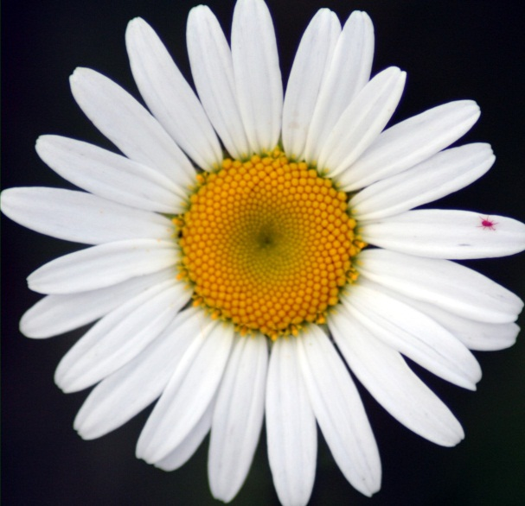](http://www.google.co.uk/url?sa=i&rct=j&q=daisy&source=images&cd=&cad=rja&docid=rTwZ93ur6eMngM&tbnid=-uJKIAVBNjKCsM:&ved=0CAUQjRw&url=http://rock.rapgenius.com/1797560/Justin-timberlake-that-girl/My-little-daisy-come-here-let-me-rock-you-like-a-baby-baby-baby&ei=MtYyUp2uC-aQ7AbNDw&bvm=bv.52164340,d.ZGU&psig=AFQjCNHUaTi2ybzDEnHwXkvRrtwBneaSSw&ust=1379149712386845)

“..surprising me by opening up in a flower-like way.” Does the name ‘Daisy’ suit the character?

“What do people plan?” (p17) How does Daisy spend her days?

“I saw that turbulent emotions possessed her.” (p21)

Consider Nick’s response to Daisy’s outburst on p22. How does this influence the reader’s impression of Daisy in chapter one?

“- that’s the best thing a girl can be in this world, a beautiful little fool.” (p22) Does this description suit Daisy?

[](http://www.google.co.uk/url?sa=i&rct=j&q=jay%20gatsby&source=images&cd=&cad=rja&docid=mztIN0y3lG8K1M&tbnid=c3z1oAOHGaqd8M:&ved=0CAUQjRw&url=http://www.entrepreneur.com/slideshow/226638&ei=I9MyUv6lBsHIhAe784DgDA&bvm=bv.52164340,d.ZGU&psig=AFQjCNGx6FndBW7kzP6gz7V6OmnT1l8tmQ&ust=1379148958874165)

What is the significance of the green light (which will be mentioned again?) Consider the symbolic quality of green.

How does Nick present Gatsby to the reader on his first sighting of his neighbour?

What does Gatsby’s home suggest about the character? Consider location and appearance in your answer. Compare this description with that of the Buchanan’s house on p12.

What does Nick admire about Gatsby? How does this reinforce a point already made by the narrator? Use quotations to assist your explanation (p7-8).