Female Characters in Gothic Texts
Gothic fiction has become a popular area for feminist studies. Many commentators have noticed how females in Gothic fiction often fall into one of two categories: the trembling and innocent victim or the shameless and dangerous predator. However, others have noticed how women writers have often used the Gothic to explore aspects of femininity and sexuality. The mad woman in the attic in Jane Eyre has become a key symbol of Gothic feminism.

The persecuted maiden
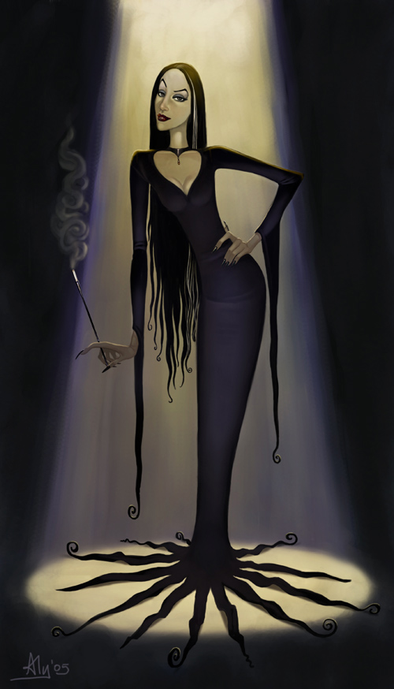The trembling victim: frail, blonde, silent, passive, helpless and innocent.
Fear and terror portrayed through her often over exaggerated reactions.
She is often shown fleeing a rapacious and predatory male.
However, at times she is made to feel sympathy for the monster which pursues her.
Typical examples include: Mina in Dracula, Elizabeth in Frankenstein, Ophelia in Hamlet, Fay Wray in King Kong

The femme fatale
The other typical gothic female is sharply contrasting female predator.
Dark haired, red lipped, wearing a tight black dress and with a startling cleavage – parodied by Morticia in the Addams family.
A dangerous and rapacious creature, offering a real sexual threat.
Often punished in their story for their transgressions.
Examples are: Lady Macbeth, Dracula’s brides

The mother figure
The dominating father is a key presence in the gothic but the role of the mother is also central to some narratives. In Frankenstein, Victor usurps the mother’s role by bringing the monster to life, causing an offence against nature. In Macbeth, Lady Macbeth says she would be prepared to sacrifice her children for Macbeth to be king. In many Gothic stories the mother is a destructive character. In The Monk Antonio’s mother is slaughtered; however, in The Bloody Chamber, Angela Carter changes the mother’s role - she appears as the knight in shining armour to rescue her daughter.

- Female characters play a very significant role but often ambivalent role in Gothic texts.
- The stories may play out a battle between the sexes or explore the uneasy relationship between pain and love.
- Women in the texts may be absent or marginalised.
- They may explore sexual aggression and illicit desires; they may be objects of male fantasy.
- Female characters may be used to express feeling and heighten terror.
- Some feel the powerful femme fatale represent emancipated women who no longer submit to male control.
- Female writers may use the women characters in a different way to men, to explore aspects of their own femininity and sexuality.
- The female gothic character’s role has changed from the original Gothic stories of the 18th and 19th century to Angela Carter’s The Bloody Chamber.
- Angela Carter was particularly interested in the portrayal of women as victims of male aggression as a limiting factor in the feminist perspective of the time. Her argument was that women need not accept that role and she uses The Bloody Chamber to explore how that may be achieved

Society, Culture, And The Gothic - Introduction.
Gothic Literature. Ed. Jessica Bomarito. Gale Cengage, 2006. www.enotes.com/gothic-literature
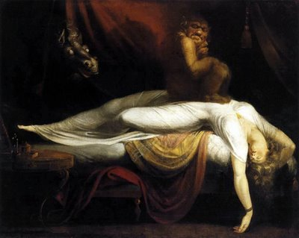Commentary on the relationship between women and the Gothic focuses on works of Gothic literature by women authors as well as on the depiction of women in Gothic literature written by men. In the mid-1800s, women had few rights and were expected to be subservient to men. Not only were women denied the vote, they were denied the right to own property. Cultural expectations required that women refrain from expressing themselves openly in the presence of men. Rather they were expected to be pure, pleasant, and supportive of men at all times. But, as reflected by the controversial Gothic novels, these rigid roles were changing. Feminist critics point out the unusual prevalence of strong female characters in Gothic novels, and the way their independent and often sexual behavior was harshly criticized by contemporaries of the novels. Modern critics also point out the way in which female sexuality was often used to denote strength, rebelliousness, and evil. Appearing as nefarious seductresses, female characters were often demons or villains who were punished or made to see the error of their ways at the story's end. Feminist critics also claim that while women in earlier novels had been portrayed as victims waiting to be rescued, in Gothic novels the roles were often reversed and the male characters were victimized. Other scholars see the validation of marriage as a common theme of Gothic novels and still others argue that the genre allowed women readers of the mid-1800s to enjoy independence vicariously through the actions of the female characters. Mary Shelley's Frankenstein; or, The Modern Prometheus (1818) has received particular attention from feminist critics, as the novel offers common themes in the female Gothic tradition: fear and anxiety surrounding the birth process, female sexuality, and women's bodies. Modern women authors employ horror and the Gothic to convey the horror of being perceived as freakish by society for engaging in and espousing artistic and vocational pursuits considered outside of the traditional—and, thus, approved—women's realm, or for choosing to delay or avoid pregnancy, marriage, or motherhood. These narratives relate the unique and deeply rooted fear and anxiety experienced by women who are afraid simultaneously of being trapped in stifling, repressive roles and of being rejected or isolated for challenging these prescribed roles. The work most frequently held as an example of female Gothic is Charlotte Perkins Gilman's novella "The Yellow Wallpaper" (1892). The novella, a fictionalized account of Gilman's real-life experience with the "rest cure," a commonly prescribed treatment for depression, horrified readers and critics when it was published, largely because the female protagonist's terror and eventual madness were chillingly true to life and offered a harsh indictment of a widely-held belief that women who found motherhood and domestic duties unfulfilling or even confining were mentally ill. Subsequent critical analyses of the work have focused upon Gilman's use of horror and Gothic elements to convey the desperation experienced by women who were both physically imprisoned and deprived of intellectual freedom and expression.

