Gothic Settings and Atmospheres in Wuthering Heights
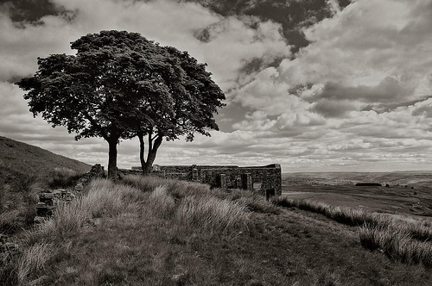
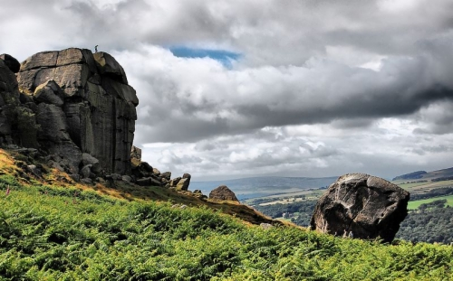

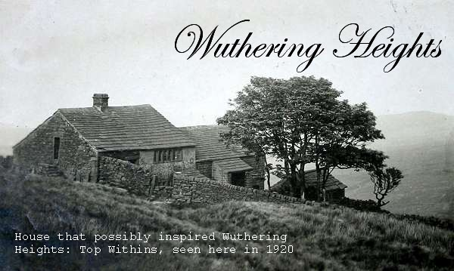
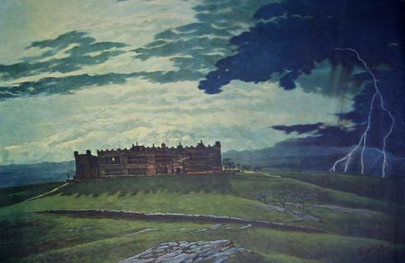

Critical Readings:
“Many critics have paid attention to Bronte’s use of landscape imagery, and the way in which landscape frequently functions as a metaphor for human behaviour or characteristivcs in this novel. Mark Schorer (1949) notes that ‘Human conditions are like the activities of the landscape, where rains flood…spirits are at high water mark…illnesses are weathered”

