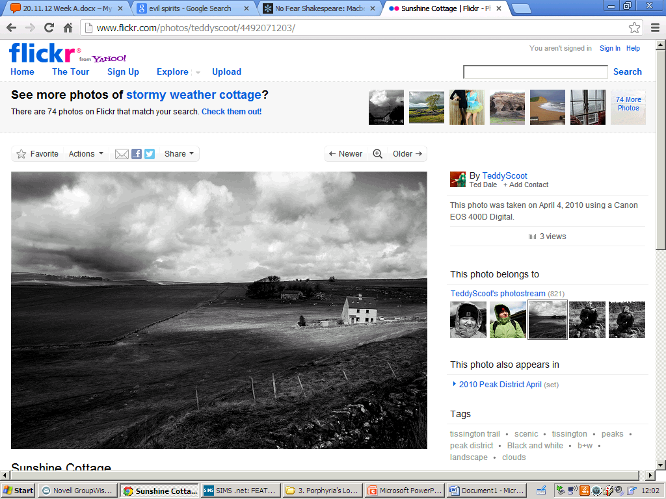

* Label the image with as many adjectives as you can.
* What do you think may happen in a scene/setting like this?
* What kind of mood or atmosphere is portrayed?
* What could a setting like this symbolise?

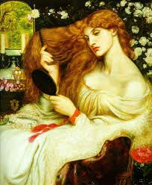

* How would you describe the image or the female figure. Label with adjectives.
* How is this character feeling?
* Why does the image focus on beauty and appearance?
* How is this significant to Browning or linked to My Last Duchess?

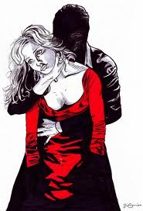

* What is happening in this image?
* Explore the theme of power – how is it being demonstrated?
* Link to Browning – how would an image like this interest him?