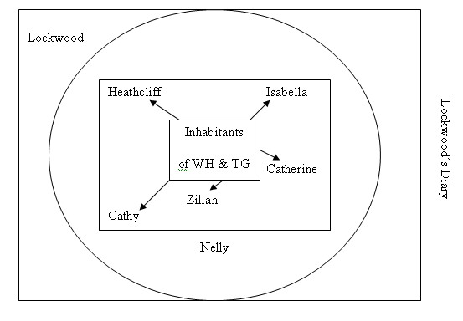
Narrative Structure in Wuthering Heights

The Big Question: How does the narrative structure of WH link to the gothic nature of the text?

